# Use Case Design Specification

## **Load Distribution Scan for X <Customer Inquiry Load> (**X can be any numeric value**)**

Step 0: There are rules in the Graph DB to indicate the load distribution formula, such rules and load distribution percentage is represented in graph structure, refer to below:

match (n:Rule) return n

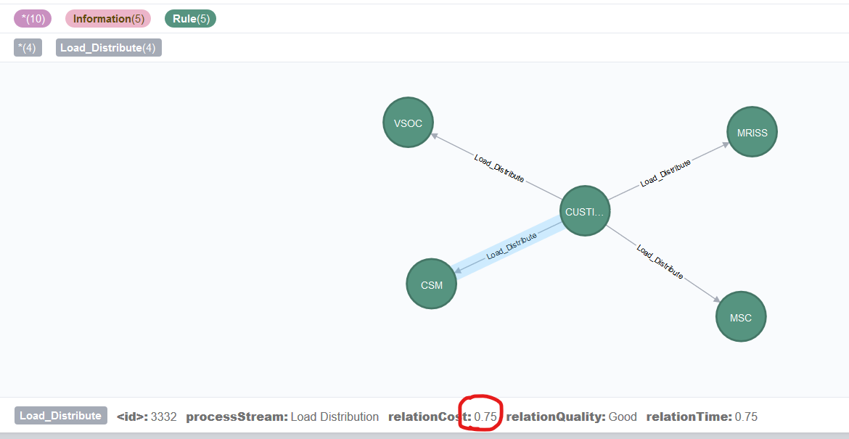

This rule means, if user input “Load Distribution Scan for X Customer Inquiry Load”, then the X number of load will be distributed to 4 nodes indicated in the graph rule, the 4 nodes can be Process, Technology or People.

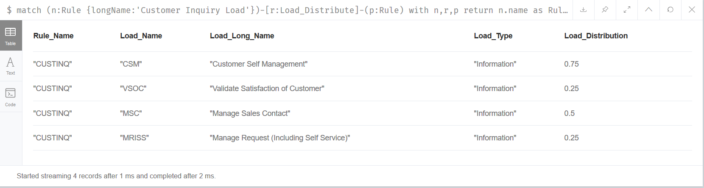

Step 1: For example, if user input “Load Distribution Scan for **1000** Customer Inquiry Load”

#1.1 Delete the previous load if any:

match (a) - [r0:Load_On] - () detach delete a

#1.2 Apply the Load Distribution rules and create Load to the specified People/Process/Technology node using below cypher:

MATCH (n:Rule {longName:'Customer Inquiry Load'} )-[r:Load_Distribute]->(p:Rule) with p,r match (o {nodeID:toInteger(p.leaf)}) create (l:Information:LOAD {name:1000*r.relationCost})-[r1:Load_On {relationCost:100*r.relationCost}]-> (o) return o,l

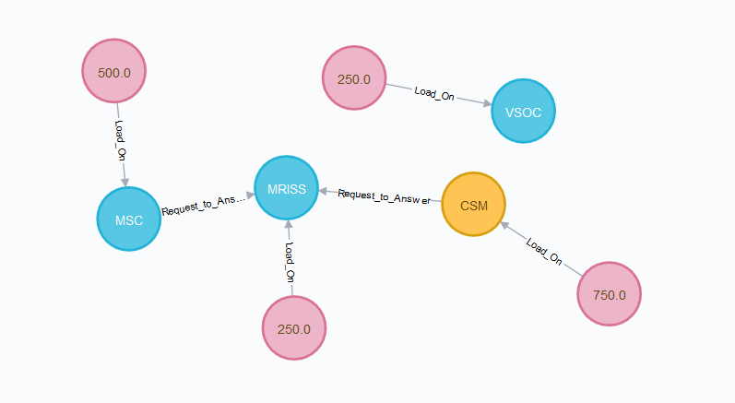

Step 2: Display the following result in the Web UI with graph view and one summary statement, as well as a table that illustrates the scan result details

match (n) -[r:Load_On]->(p) with n,p return p.name as Load_Name, p.longName as Load_Long_Name, labels(p)[0] as Load_Type,p.shortDescription as Load_Description, n.name as Load order by Load desc

**Load Distribution Summary**: The following table shows the impacted nodes that supports the 1000 number of Customer Inquiry Load, and the load distribution is ranked in a descendant order

